Curriculum Vitae
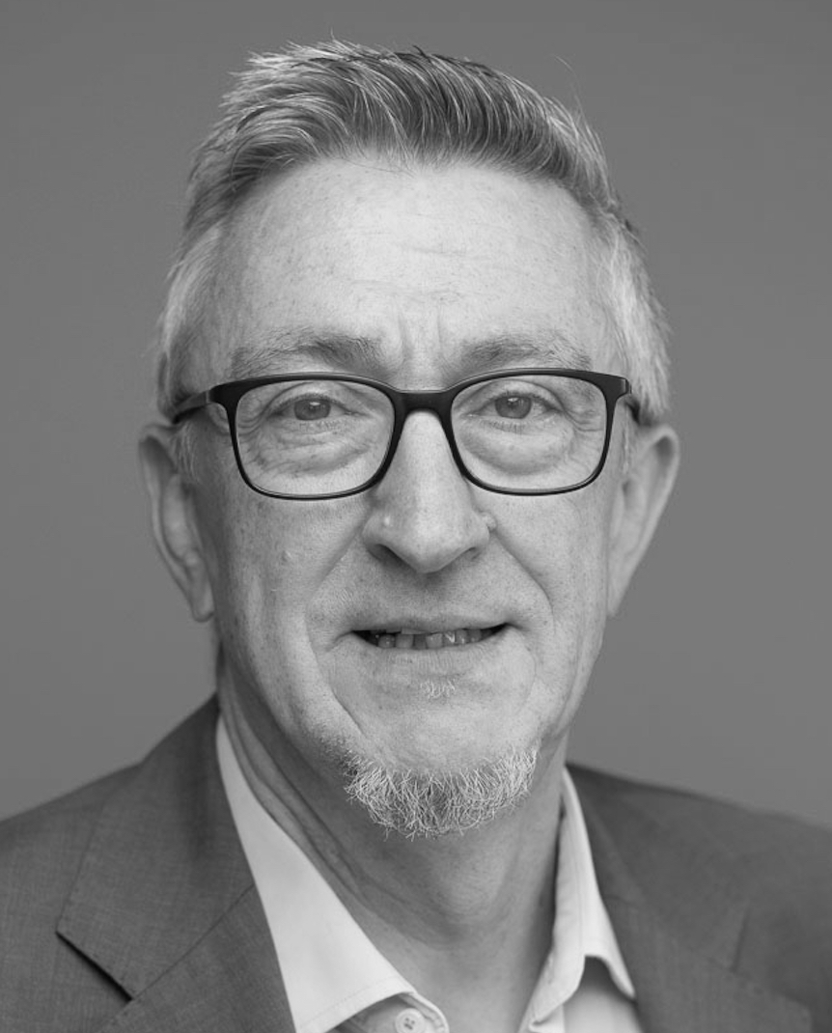

Name | Markus Klein
Address | Auenstrasse 203
 | 85354 Freising
 | Germany
e-mail | m_klein@web.de
Phone | +49 155 – 63090 736
Marital status | Married, one daughter

Professional Summary
Visionary and entrepreneurial leader with over 20 years of international experience in leading diverse Systems & Solution Engineering teams. Proven track record in driving revenue growth, leading high-performing teams, and transforming organizations to SaaS-based, customer-centric models. Adept at fostering innovation, collaboration, and alignment across global teams and partner ecosystems to deliver exceptional business results. Experienced in positioning and selling existing and new solutions for both perpetual and subscription licensing models.

Experience
EMEA Lead, Partner and Commercial Solution Engineers, VMware by Broadcom (Nov 2023 – Jun 2025)
During Broadcom’s acquisition, took over responsibility of the newly established EMEA Partner and Commercial Solution Engineers to build team from ground up.
- Lead a team of ~30 Partner Solution Engineers, focusing on the VMware by Broadcom Channel, partner readiness and demand generation across Europe, Middle East and Africa
- Developed innovative formats for Commercial Business, including webinars and solution-centric workshops
- Leading the new Knights program for EMEA, which is rewarding the strongest VMware Consultants in the channel

Key Achievements
- Re-established the VMware by Broadcom Channel in EMEA after the acquisition, achieving 200% of target in the first fiscal year
- Established a real SE team through regular activities like role alignment, shared goals and all-hands meetings
- Personal relationship building with stakeholders of key partners to align on priorities and go to market
- Standardized go to market approach for Channel with tools like customer assessments and solution workshops incl. enabling the field on those

Senior Director, Solutions Engineering Central Europe
VMware (Sept 2014 - Oct 2023)
Responsible for DACH, Eastern Europe, Russia, in 2018 Israel was added.
- Build and grow a team of 100+ architects and presales professionals, with dotted-line responsibility for >80 specialist SE’s
- Head of Central European Presales Leadership team, consisting of 20+ Managers in multi-level organisation
- Delivered C-Level sales trainings and spearheaded Design Thinking workshops to creatively drive sales pipeline and customer engagements
- Established an EMEA-wide career development framework for all presales functions, ensuring individual growth based on all important SE KPI’s
- Established EMEA-wide Subject Matter Expert groups, focusing on key technologies and vertical segments
- Official spokesperson for VMware press briefings and keynote speaker at major industry events

Key achievements
- Transformed presales organization to a multi-solution and SaaS-driven approach, increasing customer success and adoption rates
- Continuous revenue growth greater 10% year-over-year, establishing Central Europe as the most successful region in EMEA
- Developed innovative event platforms and formats, expanding market reach and driving effective engagement
- Reduced team attrition to <5% by implementing a career development framework for all SE teams across EMEA (700+ IC’s)
- Successfully established Design Thinking in the VMware EMEA sales organisation

Director Systems Engineering Central Europe
Citrix Systems GmbH (Jul 2005 – Aug 2014)
Responsible for DACH region (plus EE until end of 2009)

- Expanded the SE team from 15 to over 30 members, maintaining an attrition rate of <5% by establishing robust team structures
- Drove consistent annual growth of >20%, achieving revenue targets
- Represented the company at press, high-profile events, delivering keynotes to audiences of up to 1,000 attendees
- Executive level conversations with customers (CXX)

Key Achievements:
- Transformed the team from product-focused to solution-oriented, enhancing overall client satisfaction and revenue generation
- Built SE teams from scratch in new regions and for new solutions, ensuring rapid and sustainable growth
- Deliver consistent story for product demos - both sales and SE’s are telling the same story, e.g. based on a virtual company

Additional Roles
- Systems Engineer, Citrix Systems GmbH (Apr 2000 – Jun 2005)
Positioning & selling virtual workplace solutions
- IT Consultant, Schumann Unternehmensberatung AG (Apr 1998 – Mar 2000)
Building DataWarehouse solutions for Deutsche Bahn AG
- Consultant, DeTeCSM (T-Systems) (Jul 1996 – Mar 1998)
Workplace rollout, Management Information Systems implementation
- Freelance IT Consultant (Feb 1995 – Jun 1996)
Development of customized Management Information Systems based on MS Excel

Education

Period |  | Occupation
Aug. 1986 June 1987 |  | Ludwig-Geissler-Schule, Hanau, Technical Diploma Mechanical Engineering (Fachoberschule)
Oct. 1987 Aug. 1989 |  | DRK Offenbach, Civilian Service
Sep. 1989 Dec. 1992 |  | FH Frankfurt, Study of Process Engineering
Jan. 1993 Jan. 1995 |  | Hartnack-School, Offenbach, IT Business Engineer

Knowledge/Interests

Languages | German – native  English – fluent in speaking and writing  French – currently learning
Trainings/Certificates | Sales and product certifications from various vendors  Various management certificates  Design Thinking-Hasso-Plattner-Institute
Other skills | Motivator and servant Leader
Hobbies | Sports – Gym, running & cycling  Cooking  Music Enthusiast: Vinyl records, live concerts, acoustic and electric guitar

References available upon request.

Freising, February 2026


